Input paper: [1] ENAV19-13.12

Input paper for the following Committee(s): check as appropriate Purpose of paper:

**□** ARM **□** ENG **□** PAP **□** Input

**x** ENAV **□** VTS **x** Information

Agenda item [2] 13

Technical Domain / Task Number 2 3.1.11, 4.1.1

Author(s) / Submitter(s) Maritime and Port Authority of Singapore, Furuno, Tideland (contact Paul F Mueller paulm@tidelandsignal.com)

Singapore eRadar and eRacon Sea Trials October 2015

# Summary

The Maritime and Port Authority of Singapore (MPA), together with Furuno and Tideland Signal, carried out joint sea trials for eRadar/eRacon performance evaluation. The sea trials are extensions to the previous trials done in Denmark (EfficienSeas Project, 2011, Reference 1) and United Kingdom (ACCSEAS Project, 2013, Reference 2), where the Singapore sea trials were carried out in a busy port environment.

## Purpose of the document

Recognizing the critical need for real-time accurate, terrestrial-based positioning to complement GNSS positioning (Resilient PNT), especially in port and coastal areas, a joint project Team comprising of representatives from the MPA Hydrographic Department, Furuno and Tideland Signal set the following goals for the sea trials in Singapore and they are:

1. The positions of the MPA vessel from the eRadar are to be displayed in real-time on an ECDIS display. This is a major step forward where the vessel’s e-Racon position is computed and displayed on-the-fly.
2. This sea trial area is to be conducted in a busy channel environment so as to evaluate the performance of the e-Racon system under real world conditions with signal reflections from passing vessels in the vicinity. This is another step forward as previous trials were done in relatively open waters.
3. To evaluate the effect of eRacon transmission on normal radars. Previous trials were done using eRacons that were set to a specific fixed frequency to match the frequency of the test eRadar. This was done primarily to minimize the likelihood of the eRacons to respond to normal radars. For this trial, however, the eRacons were configured as frequency agile in order to operate as normal racons to other radars.
4. To study the accuracy and robustness of the positioning accuracy of eRadar/eRacon (both static and dynamic positioning) as compared to DGPS positioning. The aim is to achieve positioning differences to within +/- 2.5 meters as compared to DGPS.

## Related documents

The document ENAV-17.13.16 announced these sea trials. The presentation ENAV-18.6.9 gave a brief overview of the results of the sea trials.

# Background

Enhanced radar positioning is a proposal for a position fixing system in maritime navigation, based on radar navigation. It is the automation of the process of determining one’s own position by means of radar fixing, using a multitude of objects with known positions as reference points.

The proposal was originally made by Jens K. Jensen from the Danish Maritime Safety Administration in 2009, in relation to the need for an independent source for position fixing, due to the vulnerabilities of GPS and other satellite navigation systems, identified during the workplan conference at IALA on IMO's e-Navigation strategy.

This proposal is currently being brought forward to the maritime industry through IALA, and an opportunity for practical testing of the concept in 2011 was undertaken as part of the EfficienSea project partly financed by the Baltic Sea Region Programme and coordinated by the Danish Maritime Safety Administration. The second opportunity for practical testing was in 2013 and was considered as part of the Resilient PNT stream of the ACCSEAS project, coordinated by the General Lighthouse Authorities of the UK and Ireland.

Both of these trials were successful and demonstrated high potential for the concept.

# How eRacons and ERadars work

eRacons are essentially normal racons, modified to encode their position into the signal response to the radars that interrogated them. Position is encoded using FSK modulation in the leading dash of the racons’ Morse code response. The eRacon position is surveyed and entered as a static parameter in the eRacon configuration.

eRadar receivers detect this modulation and demodulate the position data. Knowing the azimuth and range of the eRacon target, and the heading of the vessel, the eRadar can then calculate and report the position for the vessel.

# Trial Arrangement

Three locations for eRacons were chosen: eRacon A, eRacon B and eRacon C. The eRacons were deployed on existing aids to navigation as shown in the following figure below. Note the low height of the installed eRacons, which will be discussed further later on.



eRacon A



eRaconB

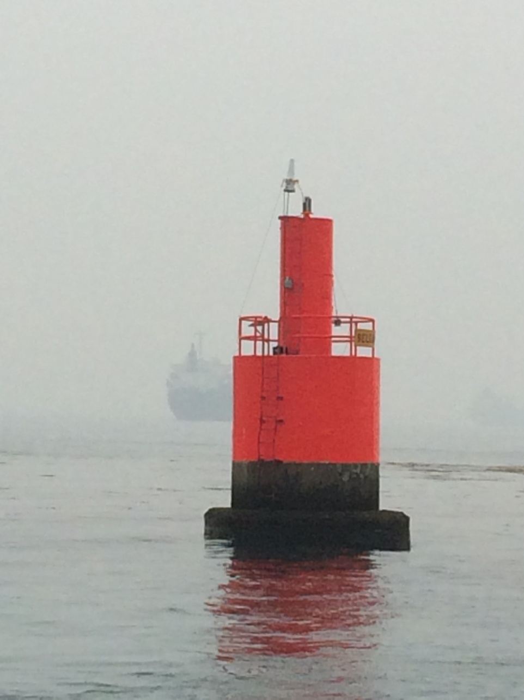

eRacon C

1. : Sea trial area and locations of eRacons

# DISCUSSION

The eRacons were installed and were apparently responding normally to radars in the area. The eRadar was turned on but there was no response. One of the eRacons was reconfigured to fixed frequency from frequency agile mode) and the radar responses started streaming in properly. The other two eRacons were also reconfigured. The trials were then completed using the eRacons in fixed frequency mode. The rate of responses was rather poor at certain areas, probably due to multi-pathing issues in the busy harbour. However, the eRadar was able to provide position solutions. A few difficulties were encountered as follows.

## Failure of Frequency Agile

As discussed above, there was a failure in responses to the test eRadar. This was attributed to two normal racon effects:

1. Racons are very busy and simply do not have time to respond to all pulses from all radars. This effect will cause all radars to show a low response rate from racons.
2. Side lobe suppression (SLS) can block certain radars. The purpose of SLS is to prevent responses to off-axis antenna lobes and to minimize the apparent width of the displayed racon response. Normal (SLS) operation is for racons to respond only to the strongest signals from a given radar. In order to work correctly, racons must identify individual radars, usually by frequency and pulse width. A stronger radar with a similar frequency and pulse width will completely suppress responses from a weaker radar.

There is anecdotal evidence of both if these problems in busy harbours, where they are more likely to be present.

Switching the eRacons to fixed frequency mode minimizes these effects.

## Physical Blocking Due to Low eRacon Mounting Height

Figure 2, below, shows a track recorded while the test vessel was in motion. Note the irregular spacing and gaps in the position solutions (colour indicates magnitude of error with respect to DGPS). Many of the missing responses are thought to be due to blockage of signals by vessels located between the eRadar and eRacons. There may also be some multi-path fading. This is a normal problem when using racons. A solution may entail mounting the eRacons at a height above an average vessel’s deck height.

## Reflections from Vessels

Figure 3 below show the effects from reflections off vessels and background structures. This is a normal radar problem. Positional accuracy can be improved by filtering the position solutions before display.

## Geometric Issues

In Figure 2, note the rather high errors on direct lines between eRacons A and B and between eRacons B and C. These are areas where there is a higher horizontal dilution of precision. Strategic placement of eRacons can reduce this problem.

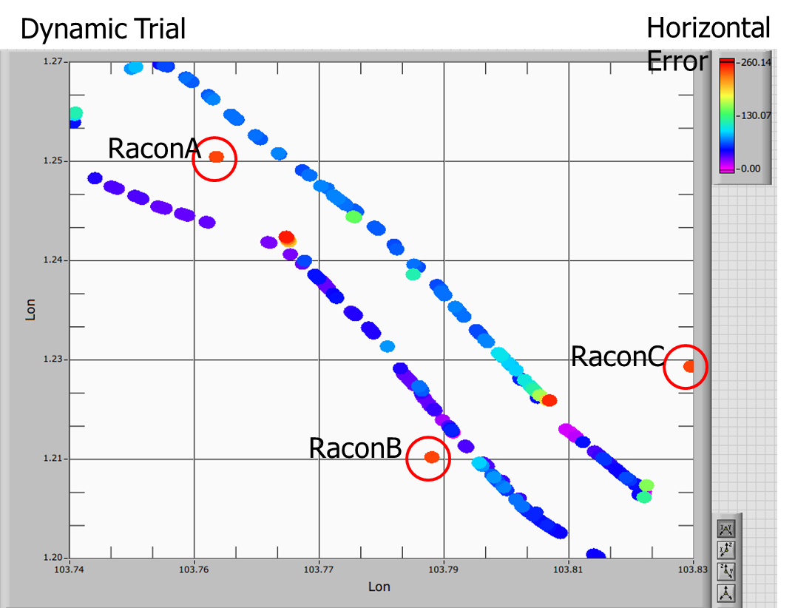

1. : Typical Solution Track

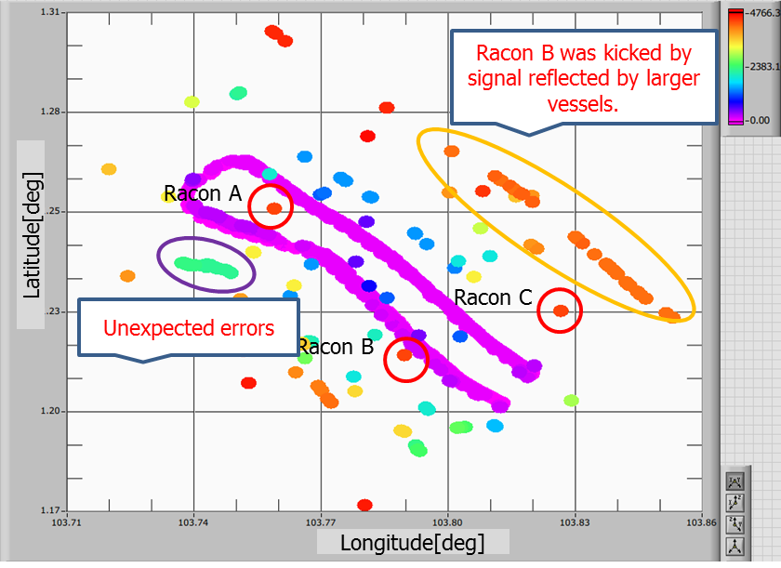

1. : Effects of Signal Reflections

# SUmmary

The sea trial was a success, displaying real-time positioning on the ECDIS and relatively good accuracy using multiple eRacons, as shown in Figure 4, following.



1. : Test Result Summary

However a goal of this trial was not achieved – that of operating in frequency agile mode. Frequency agile mode is necessary for practical usage of eRacons and we would be carrying out further development and tests to address this.

# References

1. E-Navigation Underway, January 2012, Enhanced Radar Positioning as an e-Navigation Service, Jens K. Jensen, Danish Maritime Authority
2. Radar Positioning - Trials results and feasibility analysis, IALA e-NAV14-9.7.1, Nick Ward, GLA

# Action requested of the Committee

This paper is for information only and requires no action by the Committee.

1. Input document number, to be assigned by the Committee Secretary
2. Leave open if uncertain